Moscow Metro Station Classification

1. Introduction
  - Back Ground
Moscow is a capital of the Russia. Moscow Metro is one of the largest public transcript systems in the world. This metro system consisting 261 station in Moscow. About more than 6 Million people use this system on daily bases. These metros connect all neighborhood in Moscow. It covers many restaurant, hotels, bars and hospitals.

  - Problem
Based on data of venues near to Metro station we can classify metro stations. By these classifications we identify that some neighborhoods are mostly residential, some have business and commercial places around them. The venues closest to a station determine why and how people use it. So, this information provides primary usages of station. For example, stations which are in between residential area are used for travel to home.

  - Interest
These classifications provide help to city planners to determine people travel from where to where. Based on this information it provides facility in new development. So, Moscow government will take interest in this business solution.

2. Data acquisition and cleaning

2.1 Data Sources
For data of Moscow Metro station location we have used data from Wikipedia page(https://en.wikipedia.org/wiki/List_of_Moscow_Metro_stations). And for neighborhood data we have used Foursquare data.

2.2 Data Explanation
In Metro station location data, it contains name of station in English and Russian Cyrillic, opened date, transfer line, Line of station, Type of station and Coordinates of stations.

In foursquare data it contains categories type of venues near to stations, In categories Top level categories are 10, other than this also have information about sub categories. For square also provides number of venues near to station according with its categories type.

3. Methodology
Classification is a method of supervised learning. So, in supervised learning we needed labeled data. But we did not have label data. So, I have used KMeans clustering method. It is unsupervised learning method.

We start with scraping Wikipedia page and collect Moscow metro station data. And remove unnecessary data. So, we have Station name, Line number, and Coordinates. Then I have drawn all lines of station to visualize my data.

Using Foursquare API, I have fetch query of categories of venues. There are main ten types of categories. They are main types of categories. All ten categories contain sub categories. But now we do not discuss about sub categories. Ten main categories are given below.

- Arts & Entertainment,
- College & University,
- Event,
- Food,
- Nightlife Spot,
- Outdoors & Recreation,
- Professional & Other Places
- Residence
- Shop & Service
- Travel & Transport

Now Using ids of these categories, we have fetched number of venues of each category around each station. Now our whole data is ready.

4. Results
So, we use KMeans clustering algorithm. We create 5 cluster. Analysis result of these cluster are given below.

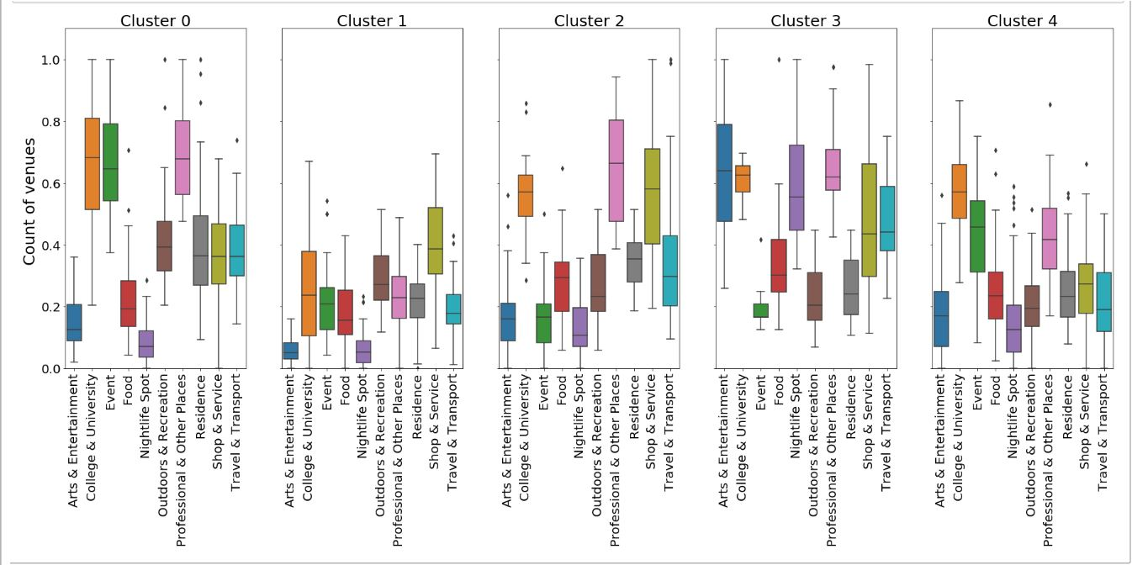

In Below images all station which are in same cluster are given in a same colour.
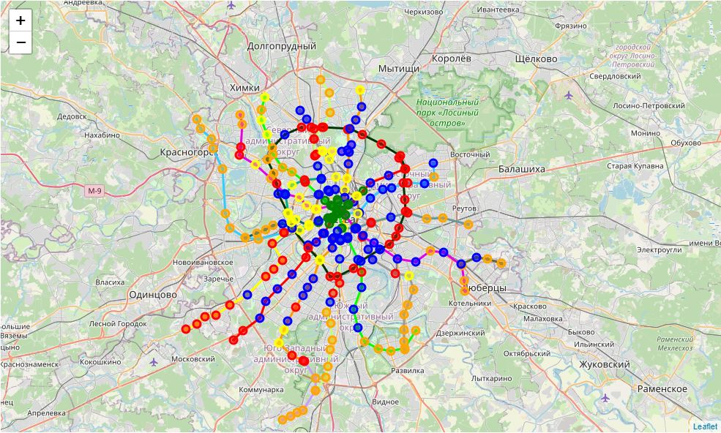

5. Discussion
To be fair, Foursquare data isn’t all-encompassing. The highest number of venues are in the Food and Shop & Service categories. Data doesn’t take into account a venue’s size (e.g. a university building attracts a lot more people that a hot dog stand — each of them is still one Foursquare “venue”).

6. Conclusion
Foursquare data is limited but can provide insights into a city’s development. This data could be combined with other sources (e.g. city data on number of residents) to provide more accurate results.

